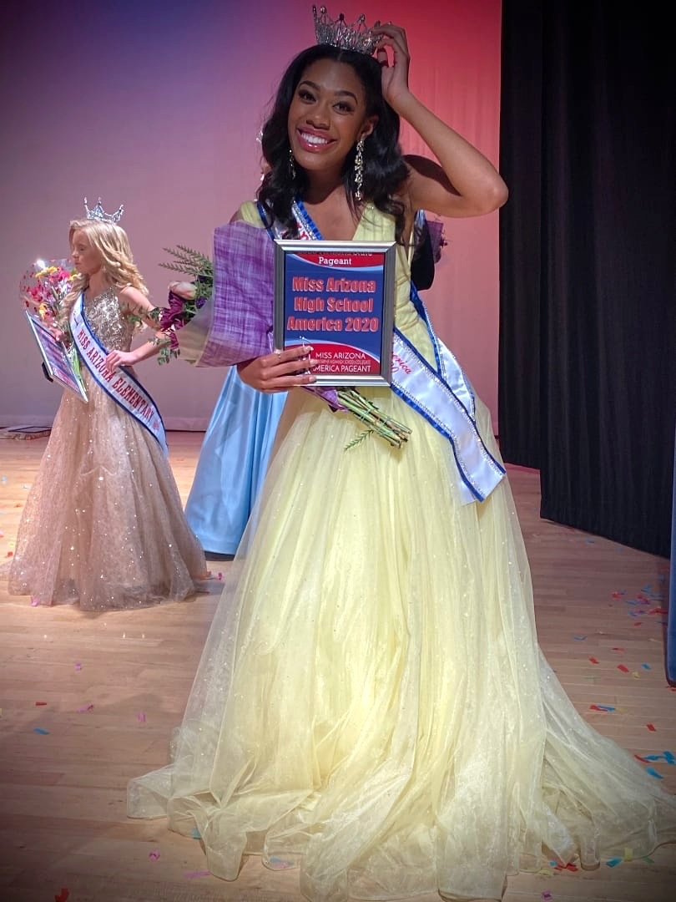
Arcadia High School junior crowned
Miss Arizona High School America 2020

FOR IMMEDIATE RELEASE
September 30, 2019
(Gilbert, Arizona) — September 29, 2019 – Arcadia High School student Chloe Hiller of Phoenix was crowned on stage as Miss Arizona High School America 2020.
15-year-old Chloe Hiller has been competing in pageants for the past seven years, and is the creator of the hashtag #GirlsDreamBelieveandAchieve social media movement. Her aim is to empower her followers to dream big and believe in themselves to achieve their goals. During her pre-teen years, she experienced bullying and through pageantry she was inspired to share those experiences to help others. Chloe was a recipient of the Girls Rule Foundation Brilliant, Beautiful and Bold Role Model Award, which is given to four exceptional Arizona girls ages 12-18 who make a difference in their community. Her current pageant platform incorporates the acronym B.R.A.V.E. which stands for Building Respect And Values for Everyone – she will continue to empower others by promoting B.R.A.V.E. at schools, various events and appearances around the state.
Chloe will represent Arizona at the National Miss High School America Pageant in Little Rock, Arkansas in June 2020. During the National competition, delegates from all 51 states will be scored in three categories – judges’ interview, evening gown and fun fashion/ modeling. Miss High School America 2020 will walk away with a prize package of over $85,000 in scholarships, travel, wardrobe and additional prizes.
Miss High School America Scholarship Pageant
The Miss High School America Scholarship Pageant Organization was started in 2009, for the purpose of providing personal and professional opportunities for young women. It is our goal to provide outstanding junior high, high school and collegiate girls the opportunity to compete in a prestigious national level scholarship pageant. For more information you can visit www.americashighschoolpageant.com. To contact Chloe Hiller for appearances and classroom visits, email missazhigh@gmail.com or call (602) 403-7848.
– ### –

